Can a Precise Knee ACL Stem Cell Injection Regrow a Torn ACL?
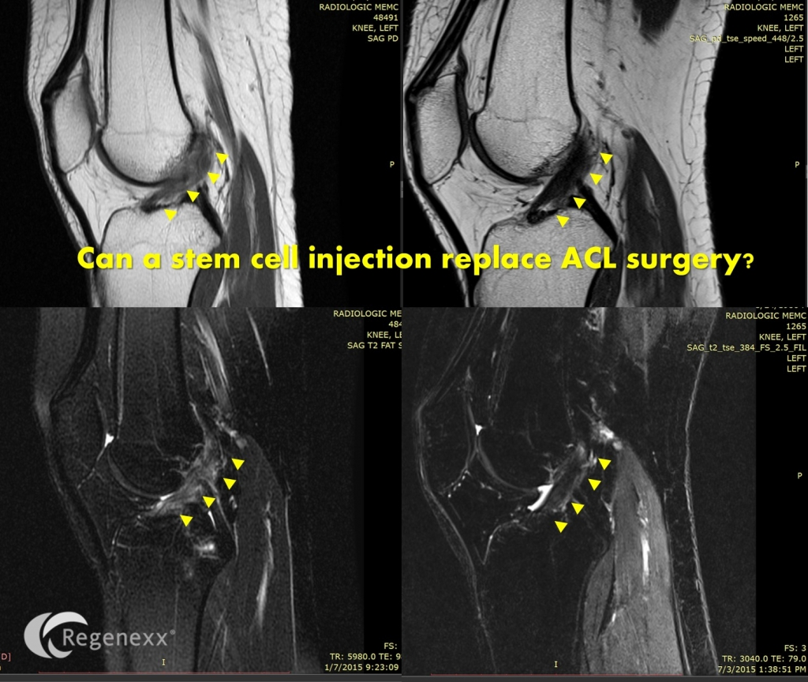
I’ve blogged before about our great success in using knee ACL stem cell injections to help torn knee ACL ligaments mend without surgery. This week I received the above MRI on a patient from Singapore who didn’t want traditional surgery to remove her torn ACL, but wanted to try to heal her original equipment. The MRI, as others have shown in the past, shows impressive results.
The ACL is the main stabilizing ligament of the middle of the knee. It prevents the bottom knee bone (tibia) from slipping forward on the top knee bone (femur). It also provides rotational stability with running/cutting. When it tears completely, the most common treatment worldwide is surgery to remove the original ligament and insert an artificial one. However, while most of the public believes that getting a new ACL is like replacing a broken part in their car, the reality is that the new ligament is never as good as the original. In fact, ACL surgery patients often never regain normal propioception (position sense) or strength. In addition, few patients get back to the same level of sports after ACL surgery. Finally, about 2/3’rds of younger patients who get ACL surgery will have arthritis by the time they’re 30.
MO is a 28 year old from Singapore who was skiing in December 2014 and heard two pops. An MRI showed a full thickness ACL tear, so she was offered surgery. However, a little on-line research showed that ACL surgery isn’t all it’s cracked up to be. So she traveled half-way around the globe to Colorado, to get the precise ACL stem cell injection we have pioneered. She was injected under exacting fluoroscopic guidance using the Regenexx-ACL procedure in February of 2015 by the author of this blog. Her 5 month MRI is above. The before image shows a blown out and completely torn ACL ligament along the yellow triangles. The after image shows a robust, dark, and normal appearing ACL that was read by the reading radiologist in Singapore as normal.
The upshot? It looks like travelling from Singapore to the states was a good decision. MOs ACL now looks normal on MRI except for one little white spot we will touch up in a few months if it doesn’t fill in on it’s own. In the meantime, surgery has been cancelled and she’s thrilled!

